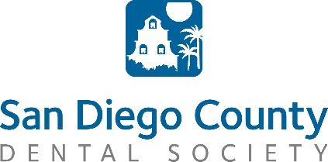
Contract: Basic Life Support Renewal-Sponsor

Please return this signed contract to advertising@sdcds.org

By participating as a sponsor at our BLS Renewal events, you have the opportunity to meet face to face with 30-50 dentists and staff in San Diego County, each meeting!
This is your chance to promote your company in person, through authentic connections.

All courses are held at the SDCDS office unless otherwise noted.
Registration and light dinner: 5:30pm | Course: 6:00pm -9:00pm

SDCDS 2017 BLS Calendar

February 16th
March 25th
May 25th
August 24th
October 27th

SPONSORSHIP GUIDELINES

Individual Meeting Sponsor - $200
5-10 minute presentation will be provided for one meeting. 1-2 representatives are welcome. You have the opportunity to meet with participants during registration and after the course if you wish to stay.

TOTAL : $

Company Name:
Contact Person:

Email Address:

Address:
City:
State:
Zip:
Phone:
Fax:
Please Bill (circle one): Mastercard Visa Amex

Card #:
Exp Date:
Sec. Code:
Or make a check payable to SDCDS and send to:
San Diego County Dental Society
1275 W. Morena Blvd Ste. B
San Diego, CA 92110

I understand and agree to the above terms:
Signature: Date:

